v.3.03

Innovation Centres
(InnoC)
  - Concept

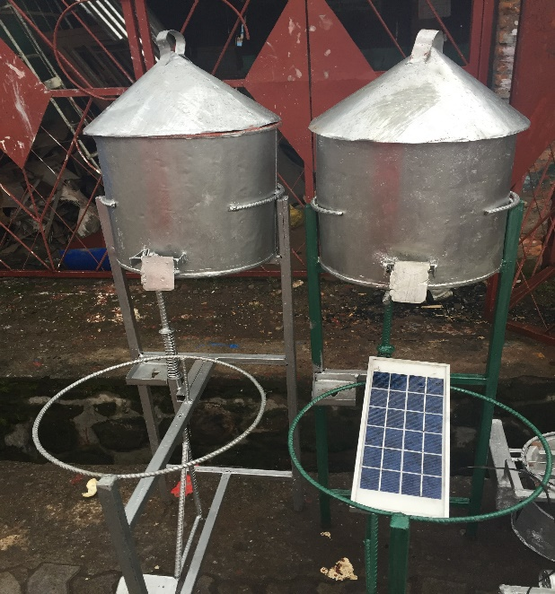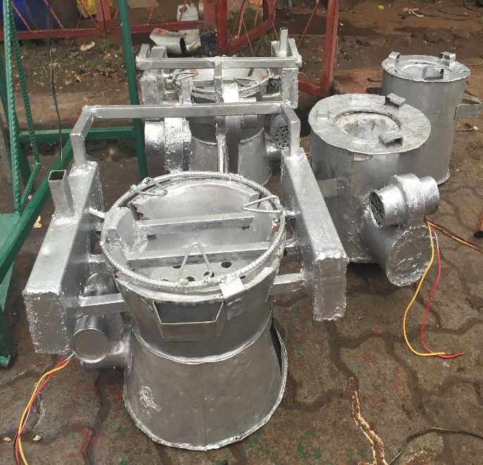

Photo : Street vendor items in Musanze, Rwanda 2015.

Introduction
Human Rights and Science (HR&S) and its Programme partners are jointly setting up HR&S Innovation Centres in non-OECD countries at locations where opportunities are scarce. We partner up with researchers, innovators and entrepreneurs at these locations with the purpose of ensuring the means necessary for the implementation of their ideas.

InnoC offer to Target partners

Co-working space
Innovation Centres Co-working space for Target partners
HR&S runs Innovation Centres (InnoC) in non-OECD countries where innovators with innovation ideas, researchers with scientific findings and entrepreneurs with business ideas, are welcome to become members. The centres are co-working spaces that provide the required tools for researchers, innovators and entrepreneurs to implement ideas in actual practice.
Our Centres shall benefit from the highest quality ICT and Tech solutions possible, ensuring that our Innovation Centre members do not lack behind the fast digital development in OECD countries. Moreover, the Innovation Centres ensure work efficiency, effectiveness, transparency and credibility.
The InnoCs offers at the BASIC LEVEL (included in membership fee)
- Physical infrastructure support including;
workspace, computer, internet connection, sustainable electricity, printer, scanner, meeting rooms, glasses, telephones, transportation vehicles, meeting rooms, accommodation and food and drinks.
- Training on;
business idea, business plan, case statement development, website creation, social media management, finance administration and accounting, intellectual property rights, patenting, copy rights, and cross-cultural understanding (CCP), structure and ethics (TAct) and evaluation planning (ROPE) .
- Networking
A platform for the members to share their findings with potential beneficiaries including the civil society, authorities, media, academia, private sector and investors. The members benefit from an international collaboration network, and an international network of advisers and experts.
- Investment capital
Access to an investment capital fund with 10 % interest. The guarantee is agreed on for each situation.

Social enterprising coaching

Business start-up
The InnoC programme supports business start-up at three levels; small, medium and large scale.
- Small-scale businesses address basic needs that are independent of advanced technical support such as; cooking food and producing soap.
- Medium-scale businesses are set up around a basic technical tool or service using available knowledge and well established procedures; such as solar panels, ecological sanitation, mills and drinking water wells. Technical equipment, such as mills and solar panels, as well as training on the services, such as solar panel maintenance and ecological sanitation installations, are offered through the InnoC.
- The large-scale businesses address new scientific results and innovations that can be made operational and distributed.

BASER franchising programme
In the BASER franchising programme entrepreneurs are provided with skills and coaching to offers basic services such as; safe drinking water, nutritious food, toilets and hygiene opportunities, transportation, internet and electricity. BASER is presented elsewhere.

Social security
- Health care emergence fund
The InnoCs addresses social security and offers a health emergency fund for its members; in case of social emergency, the members can borrow money from the fund. The loan is paid back within three months’ time and without interest. The InnoC addresses social comfort and provides awareness workshops on cross-cultural understanding; gender equity; alienation and performance stress prevention; domestic violence and early pregnancies prevention. The InnoC also address work ethics and provides awareness workshops on leadership, time management, transparency and accountability, long term planning, knowledge sharing, truth and trust, equal partnership, expectations and core values.
- Women network. The InnoC put special emphasis on supporting women researchers, innovator and entrepreneurs by offering platforms for women networking. Men are welcome to participate and the programme addresses the special needs of women. PPs and TPs in previous programmes has request initiatives that provide access to children care and sanitary pads as well as raising awareness with the purpose of preventing domestic violence and sexual abuse.

Programme partner collaboration

PP networking and knowledge sharing
Programme partners use Google.docs as a co-working platform. All PPs are invited to share knowledge and inputs regarding the InnoC business plan. From this co-working platform, each PP and HR&S signs a specific agreement that concerns each specific InnoC, thus one agreement per InnoC.

InnoC start and scaling-up procedures
The InnoC programme is scaled up timely at each site.
Level ONE
The InnoCs are initially hosted by the HR&S Programme Partners (PP) in their offices and the programme is small scale.
- The PP arranges visibility events.
- Potential Target partners are invited for start-up discussions.
- The Target partners may be invited to become members,
depending on their business proposal.
A membership fee is applied.
- Trainings are offered
by the Programme partners and HR&S travelling staff and interns.
Country training programmes have been developed by the Programme partners and address the local circumstances. Such training material is compiled and shared between the PPs in the different countries.
International training programme and training material have been developed by HR&S and addresses structure and operations according to international procedures and standards.
The trainings are given for free to the members and with fee for non-members.
The trainings generate income.
- HR&S provides investment capital for the InnoC members.

Finances

Income

Start-up
- Grants and donations are applied for to equip of the Centres;
Spider and Microsoft Sweden.
- Donations are applied for to generate the Investment capital through ActionInvest.
The ActionInvest is managed as crowd-funding through the HR&S website.

Running PP
- Membership fees
- Direct training fees by PP trainers, free for members paid by non-members only.
- Renting out venue to non-members.

Running HR&S
- Investment capital interest (10%)
- Direct training fees by HR&S trainers, free for members and paid by non-members only.
- Development organisation trainings
INASP
- External development programme evaluation

Expenses

Start-up

Running PP
- Admin
- Maintaining the Centre

Running HR&S
- Admin
- Travelling

Level TWO
As funding is secured the InnoC move to larger rented spaces.
The programme scales-up to the second level, where all aspects of the InnoC are offered at medium-scale.
  - All of the services offered at Level ONE is also offered at Level TWO.
  - Additional grants are applied for.

Level THREE
As the programmes shows sustainability it is scaled-up to the third level, where all aspects of the InnoC are offered to the highest level possible with advanced and quality equipment and services.
Land is bought and houses are constructed that keeps both shared-workspace, room for venues, accommodation and restaurant.
  - All of the services offered at Level TWO is also offered at Level THREE.
  - Complementary businesses are developed such as restaurant and venues.
The profit shall cover the running cost of the Centre.
  - Tourist travels are arranged and the profit targets the equipment procurement and installations. The visitors occupy the accommodation space in the InnoC. Tours around the country are offered as well as visits to our programmes.
  - Additional grants are applied for.

Location and development level

Present locations and status
Compilation of location and status of each InnoC.
Location | Partner organisation |  | Status | Country adviser
 |  | Contact person
East Africa Cluster ONE |  |  |  |  | Location
Kenya |  |  |  | Petronella NYAKUNDI | Stockholm
 |  |  |  | Purity MTAKAI | Stockholm
Molo? | Livelihood Improvement Programme (LIP) | Nancy GITHAIGA | Level ONE
Rwanda |  |  |  | Deodathe NDAZIVUNY | Kigali
 |  |  |  | Benjamin KYAMBADDE | Kigali
Muzanse | University of INES | Fabien HAGENIMANA | Level ONE
Uganda |  |  |  | Jeremiah KIMBUGWE | Mpigi
 |  |  |  | Benjamin KYAMBADDE | Kigali
 |  |  |  | Kelly-Irene SEMPANGI | Stockholm
Mpigi, | BanaPads | Richard BAALE | Level ONE
Nigeria
 |  |  |  | Charles BALOGUN | Abuja
 |  |  |  | Erezi EDOREH | Lagos
Abuja | National Institute for Pharmaceutical Research and Development (NIPRD) | Karniyus GAMANIEL | Level ONE
Lagos | Spell Africa | Elvis AUSTINS | Level ONE
West Africa Cluster ONE
Togo |  |  |  | Alexis AKOTCHAYE | Lomé
 |  |  |  | Danny BANNA | Stockholm
Tsévié | Association Solidarité Enfance et Vie (S.E.VIE) | Francois KLUTSÉ | Level ONE
Agbolowé | S.E.VIE | Francois KLUTSÉ | Level THREE preparations  Land bought  Visitor travels prepared for
West Africa Cluster TWO
Liberia |  |  |  | Sheikh Abu TURAY | Monrovia
 |  |  |  | Peter ROBERT | Stockholm
Painsville | Initiative for the Development of Former Child Soldiers (IDEFOCS) | Morris MATADI | Level ONE
Monrovia | IDEFOCS | Morris MATADI | Level TWO preprarations Renting.land  House under construction, six new computers in place
Little Bassa | IDEFOCS | Morris MATADI | Level THREE preparations Land bought

Strategic partners

National development plans
Meetings are held with the authorities in the partner countries, to ensure that the programmes are recognised, appreciated, and coordinated with the National Development Plans. Collaborative programmes and national financial support is proposed.

Special institutions providing Trainings

Institutions requesting external programme evaluation

Equipment givers
Strategic partners: Special Institutions for Equipping Centres
Spider, Microsoft Sweden.
HR&S is seeking support for the equipping of the centres.
We seek quality computers, software, internet access, electricity, printers, copy machines, and glasses.

Investment capital givers
Strategic partners: ActionInvestors
ActionSupporters programme

