v.3.04

Innovation Centres
(InnoC)
  - Concept

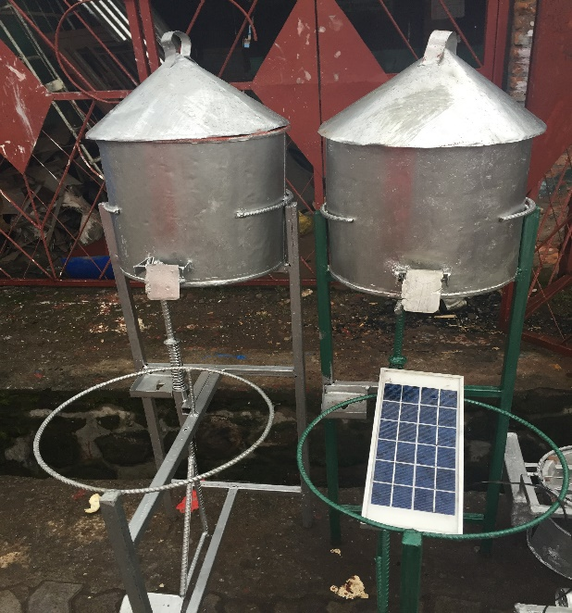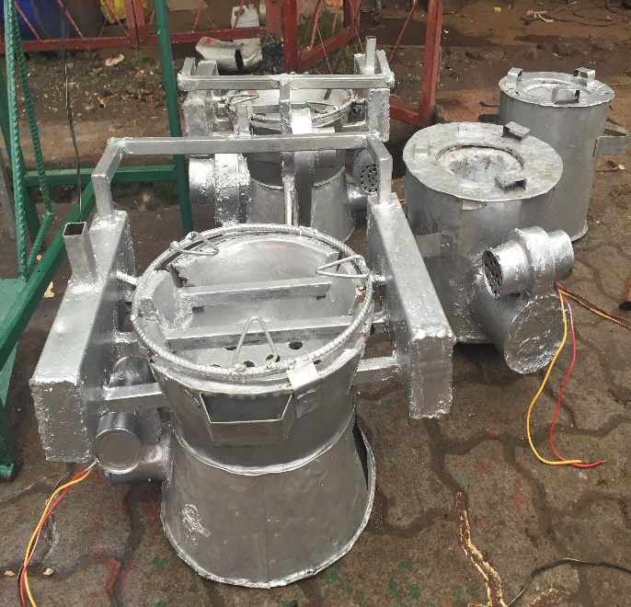

Street vendor items in Musanze, Rwanda (Photo HR&S 2015).

Introduction
Human Rights and Science (HR&S) and its Programme partners are jointly setting up HR&S Innovation Centres in non-OECD countries at locations where opportunities are scarce. We partner up with researchers, innovators and entrepreneurs at these locations with the purpose of ensuring the means necessary for the implementation of their ideas.

InnoC offer to Target partners

Co-working space
Innovation Centres Co-working space for Target partners
HR&S runs Innovation Centres (InnoC) in non-OECD countries where innovators with innovation ideas, researchers with scientific findings and entrepreneurs with business ideas, are welcome to become members. The centres are co-working spaces that provide the required tools for researchers, innovators and entrepreneurs to implement ideas in actual practice.
Our Centres shall benefit from the highest quality ICT and Tech solutions possible, ensuring that our Innovation Centre members do not lack behind the fast digital development in OECD countries. Moreover, the Innovation Centres ensure work efficiency, effectiveness, transparency and credibility.
The InnoCs offers at the BASIC LEVEL (included in membership fee)
- Physical infrastructure support including;
workspace, computer, internet connection, sustainable electricity, printer, scanner, meeting rooms, glasses, telephones, transportation vehicles, meeting rooms, accommodation and food and drinks.
- Training on;
business idea, business plan, case statement development, website creation, social media management, finance administration and accounting, intellectual property rights, patenting, copy rights, and cross-cultural understanding (CCP), structure and ethics (TAct) and evaluation planning (ROPE) .
- Networking
A platform for the members to share their findings with potential beneficiaries including the civil society, authorities, media, academia, private sector and investors. The members benefit from an international collaboration network, and an international network of advisers and experts.
- Investment capital
Access to an investment capital fund with 10 % interest. The guarantee is agreed on for each situation.

Social enterprising coaching and collaboration

Business start-up
The InnoC programme supports business start-up at three levels; Basic, Tech and Innovation. Businesses within the ‘Basic’ programme address basic needs and are independent of advanced technical support. For example; cooking food and producing soap. Coaching on sustainable economy is offered through the InnoC
Tech businesses are set up around a basic technical tool or service using available knowledge and well established procedures. For example; solar energy provider, ecological sanitation, mills and drinking water wells. Technical equipment, such as mills and solar panels, as well as training on the services, such as solar panel maintenance and ecological sanitation installations, are offered through the InnoC.
The Innovation businesses address the implementation of new scientific results and innovations that can be made operational and distributed. HR&S offers scientific capacity strengthening programmes in collaboration with academia. Coaching on the development and implementation of innovations are offered within the InnoC.

BASER franchising programme
The InnoC also run BASER franchising programmes. In the BASER franchising programme entrepreneurs are provided with skills and coaching to offers Basic and Tech services such as; safe drinking water, nutritious food, toilets and hygiene opportunities, transportation, internet and electricity. BASER is presented elsewhere.

Business Innovation programme
HR&S may develop a business relation with the Target countries Innovation companies. In this case, the two partners will share input and profit during the start-up phase. If the partners agree, that the collaboration goes well, and both sides want to strengthen the opportunity and scale up then HR&S may become a shareholder, through its Target country branch.

Social security
- Health care emergence fund
The InnoCs addresses social security and offers a health emergency fund for its members; in case of social emergency, the members can borrow money from the fund. The loan is paid back within three months’ time and without interest. The InnoC addresses social comfort and provides awareness workshops on cross-cultural understanding; gender equity; alienation and performance stress prevention; domestic violence and early pregnancies prevention. The InnoC also address work ethics and provides awareness workshops on leadership, time management, transparency and accountability, long term planning, knowledge sharing, truth and trust, equal partnership, expectations and core values.
- Women network. The InnoC put special emphasis on supporting women researchers, innovator and entrepreneurs by offering platforms for women networking. Men are welcome to participate and the programme addresses the special needs of women. PPs and TPs in previous programmes has request initiatives that provide access to children care and sanitary pads as well as raising awareness with the purpose of preventing domestic violence and sexual abuse.

Stages of InnoC implementation
The Innovation Centre are scaled up timely at each site. The implementations usually passes through three stages; Level ONE when it is hosted within the PPs premises, Level TWO where space is rented, and level THREE where land has been bought and house constructed.
Level ONE
The InnoCs are initially hosted by the HR&S Programme Partners (PP) in their premises and the programme is small scale.
- The PP arranges visibility events.
- Potential Target partners are invited for start-up discussions.
- The Target partners may be invited to become members depending on their business proposal. A membership fee is applied.
- Trainings are offered by the Programme partners and HR&S travelling staff and interns.
Country training programmes have been developed by the Programme partners and address the local circumstances. Such training material is compiled and shared between the PPs in the different countries. International training programme and training material have been developed by HR&S and addresses structure and operations according to international procedures and standards. The trainings are given for free to InnoC members and with fee to non-members.
- Tailor made coaching are offered to the InnoC member for a fee.
- The InnoC offers investment capital for the InnoC members and the interest is 10 %.

Level TWO
As funding is secured the InnoC move to larger rented spaces. The programme scales-up to the second level, where all aspects of the InnoC are offered at medium-scale.
  - All of the services offered at Level ONE is also offered at Level TWO but at a larger and more quality scale.

Level THREE
As the programmes shows sustainability it is scaled-up to the third level, where all aspects of the InnoC are offered to the highest level possible with advanced and quality equipment and services. Land is bought and houses are constructed that keeps both shared-workspace, room for venues, accommodation and restaurant.
  - All of the services offered at Level TWO is also offered at Level THREE.
  - Complementary businesses are developed such as restaurant and venues. The profit shall cover the running cost of the Centre.
  - Tourist travels are arranged and the visitors occupy the accommodation space in the InnoC.

Location and development level

Present locations and status
Compilation of location and status of each InnoC.
Location | Partner organisation |  | Status
 |  | CEO |  | Comment
West Africa Cluster
Liberia
 | Initiative for the Development of Former Child Soldiers (IDEFOCS) | Morris MATADI
Painsville |  |  | Level ONE
Monrovia |  |  | Preprarations for Level TWO | Renting.land house under construction, six new computers.
Little Bassa |  |  | Preparations for Level THREE | Land bought
Togo
 | Association Solidarité Enfance et Vie (S.E.VIE) | Francois KLUTSÉ
Tsévié |  |  | Level ONE
Agbolowé |  |  | Preparations for Level THREE | Land bought  Visitor travels offered
Nigeria Cluster
 | PSAN | Karniyus GAMANIEL
Abuja |  |  | Level TWO | Office bought by Partner
 | Spell Africa | Elvis AUSTINS
Lagos |  |  | Level ONE

East Africa Cluster

Kenya
 | Livelihood Improvement Programme (LIP) | Nancy GITHAIGA
Molo |  |  | Level ONE
Nairobi |  |  | Level ONE
Rwanda
 | University of INES | Fabien HAGENIMANA
Muzanse |  |  | Level ONE
Uganda
 | BanaPads | Richard BAALE
Mpigi, |  |  | Level ONE

Strategic partners

National development authorities
Meetings are held with the authorities in the partner countries, to ensure that the programmes are recognised, appreciated, and coordinated with the National Development Plans. Collaborative programmes and national financial support is proposed.

Institutions providing trainings
The opportunity to run trainings in the InnoC is shared with Development institutions.

Institutions requesting development programme evaluation
The opportunity of having local development programmes evaluated is shared with Institutions running programmes in Africa.

Equipment givers
HR&S is seeking support for the equipping of the centres with quality equipment, internet and electricity. We seek quality computers, software, printers, copy machines, satellite internet access, solar panels, vehicles, and glasses. Major givers are welcome to visit the centres and have free accommodation.

Investment capital givers
HR&S is seeking funding support by givers willing to contribute to the investment capital of the Centres. Crowd-funding opportunities are announced through the HR&S website. Major givers are welcome to visit the centres and have free accommodation.

